**Remediation Solution for groundwater contamination**

Miami, Florida site

Jack Lange

3/2/18

**Table of Contents**

Cover letter 3

Conclusions 4

Appendix 1 – Figures 5

Appendix 2 – Code 6

Appendix 3 – References 11

Jack Lange

Earth Science dept

University of Minnesota

Minneapolis, MN 55455

3/2/18

Site owner

Miami, Fl

Dear site owner,

A report detailing my proposed remediation strategy for the Miami, Florida groundwater contamination site is attached.

This proposed solution address the problems of contaminated groundwater in the northwest portion of the site as well as the low levels of contamination found throughout the site. In order to isolate the contaminated groundwater under your property I propose the installation of a pumping well and a recharge pond on the property. The pond and well will be placed parallel to the natural groundwater flow in the area. The pumping well will draw water from the aquifer and deposit the water in the recharge pond, which will return the water to the aquifer. The water that returns to the aquifer will again be captured by the well, and in this way the contaminated groundwater under your property will be isolated from the surrounding aquifer.

Water that is pumped by the well can be treated on site to remove contaminants before it is returned to the ground. This process will clean up the low levels of contamination that is found through the site.

A groundwater model was used to determine the optimal placement of the well and the recharge pond. In order for the well to capture only water from the recharge pond, rather than the surrounding aquifer, and for the well to capture all of the groundwater under the site, I recommend placing the well south east of the shed and the pond between the tank and the shed.

If you have any questions, please feel free to contact me.

Yours truly,

Jack Lange

**Methods**

The suggested solution was obtained using the analytic element groundwater modeling technique.

The complex potential used to describe this modeling problem included the uniform flow term, an infiltration pond, and a well. The constant term in the potential was determined based on the far field condition that head is 1.8 feet above sea level 1000 feet east of the origin. A contouring routine was used to evaluate the solution and the resulting figures are shown in appendix 1. The code for the model and the contouring routines are available in appendix 3.

Several pond-well arrangements were tried manually. The size of the pond was varied, as well as the location of the pond and the pump. The arrangement which required the least pumping to contain all of the groundwater at the site was chosen and discussed in the conclusion.

**Conclusions**

The installation of a pumping well and a recharge pond on the property is recommended to address the issue of contaminated groundwater at the site. The natural groundwater flow in the area of the site is 11.5 square feet per day towards the east. In order to prevent the contamination that is present under the site from spreading, the water underneath the site must be contained and treated. A simple and effective method for containing groundwater in a field of uniform flow is by using a recharge point placed upstream in the flow field, and a discharged point placed downstream, in line with the flow field. Water that is removed from the aquifer at the discharge point can be returned to the aquifer at the recharge point, and the captured again at the discharge point. If the distance between the recharge and discharge points is controlled, and the discharge/recharge rates are equal then the discharge point will capture all of the water from the recharge point, and only the water from the recharge point. A mathematical formulation for this solution can be found in 8.8.4 of *Analytical Groundwater Mechanics.*

An analytical model was used to determine the optimal arrangement of a discharge well and a recharge point. The optimal arrangement at this site is one which requires the lowest pumping rate to isolate all of the water under the site. The code for the model is located in appendix 2. The optimal location for the discharge point is (200,57) and the recharge point is (-9,57). The coordinates correspond to the coordinate system provided with the project map. In this arrangement, a pumping rate of 14000 cubic feet per day will ensure that contaminated water stays contained at the site, as show in figure 1.

The simplest and most cost effective option for the discharge point is an infiltration pond. An infiltration pond with radius 19 feet will fit at the discharge point and will allow the appropriate infiltration rate.

**Appendix 1 – Figures**

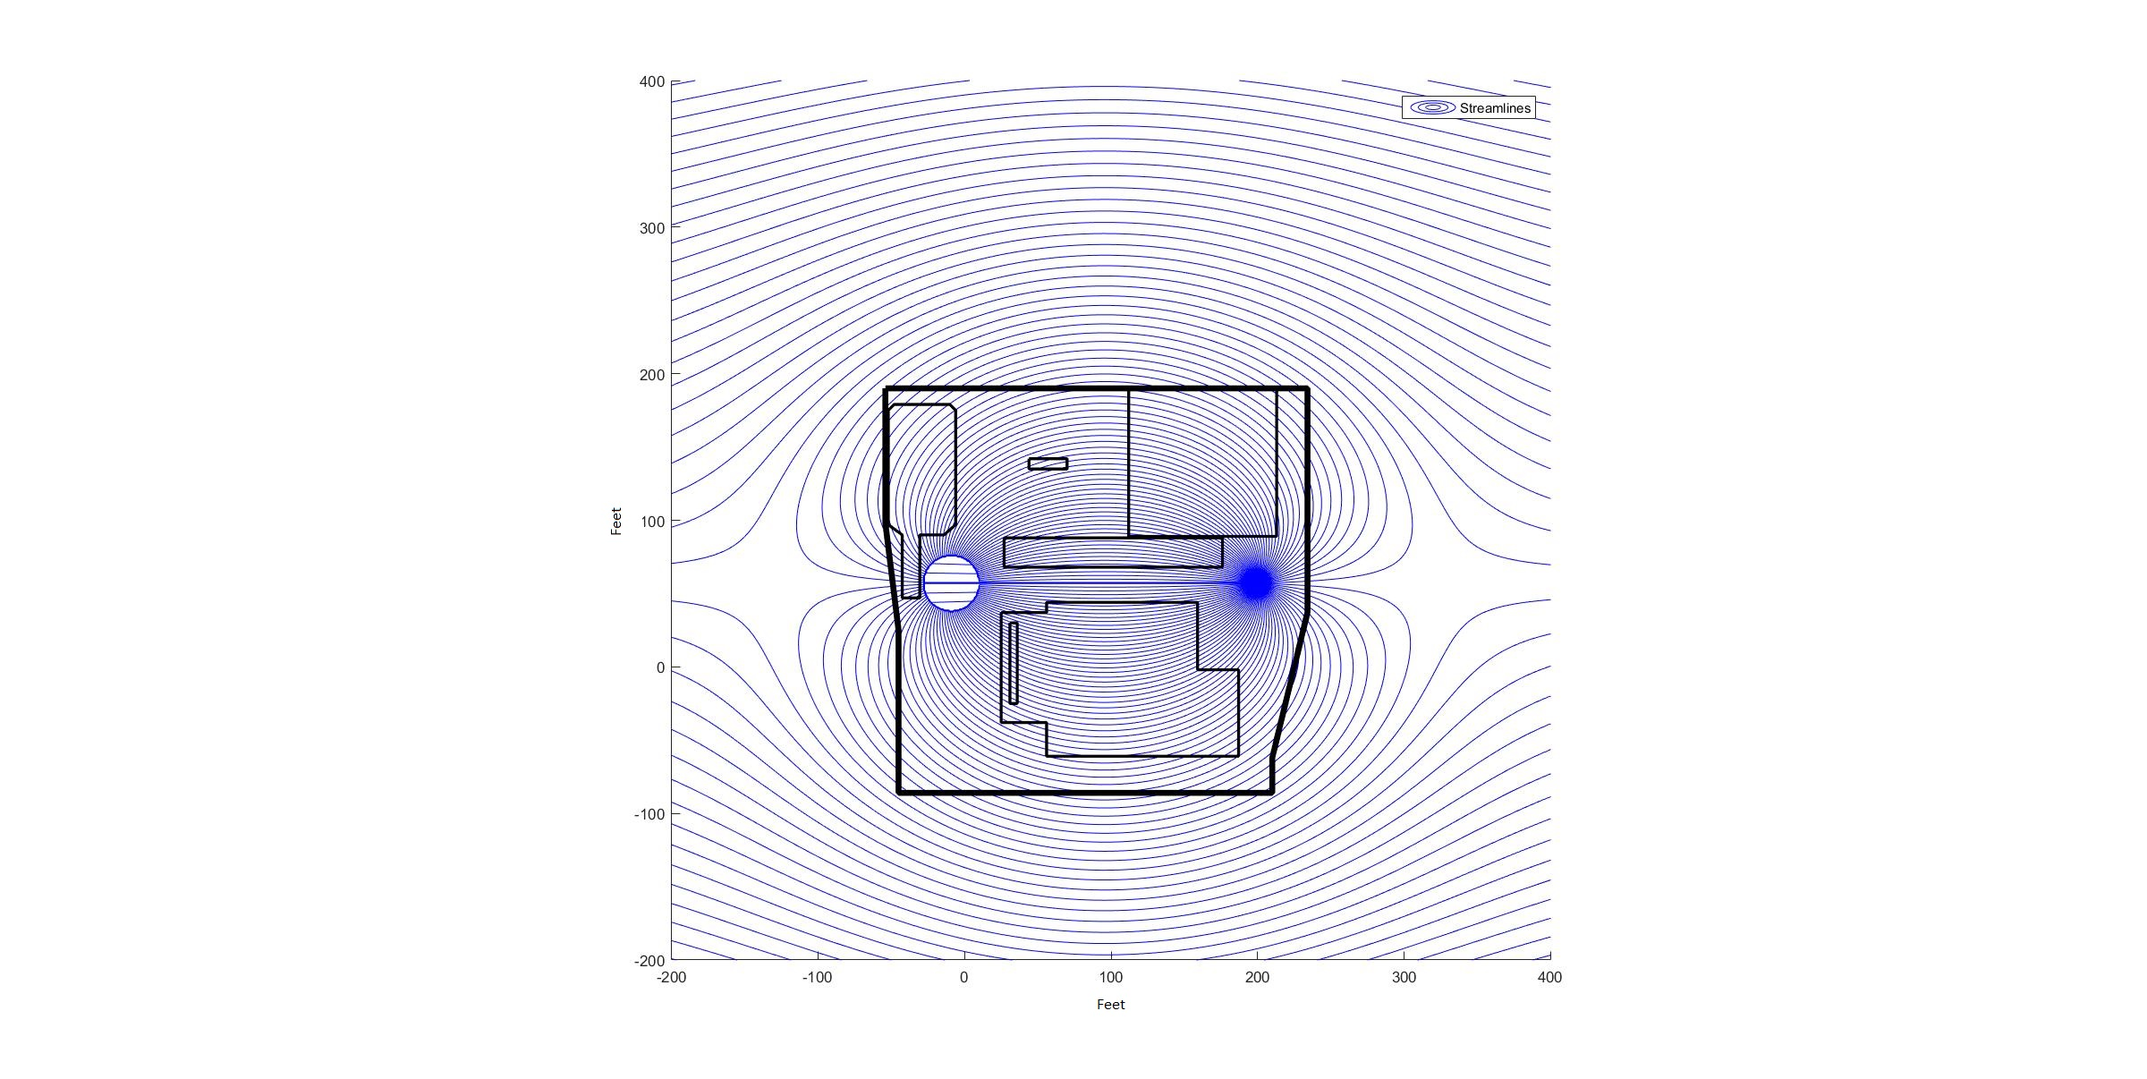

Figure 1: Streamlines for the case of pumping 14000 cubic feet per day from a well located at (200,57) and depositing the water into an infiltration pond of radius 19 feet, located at (-9,57). The property is enclosed by streamlines originating at the infiltration pond and terminating at the pumping well indicating that groundwater will not escape from the site.

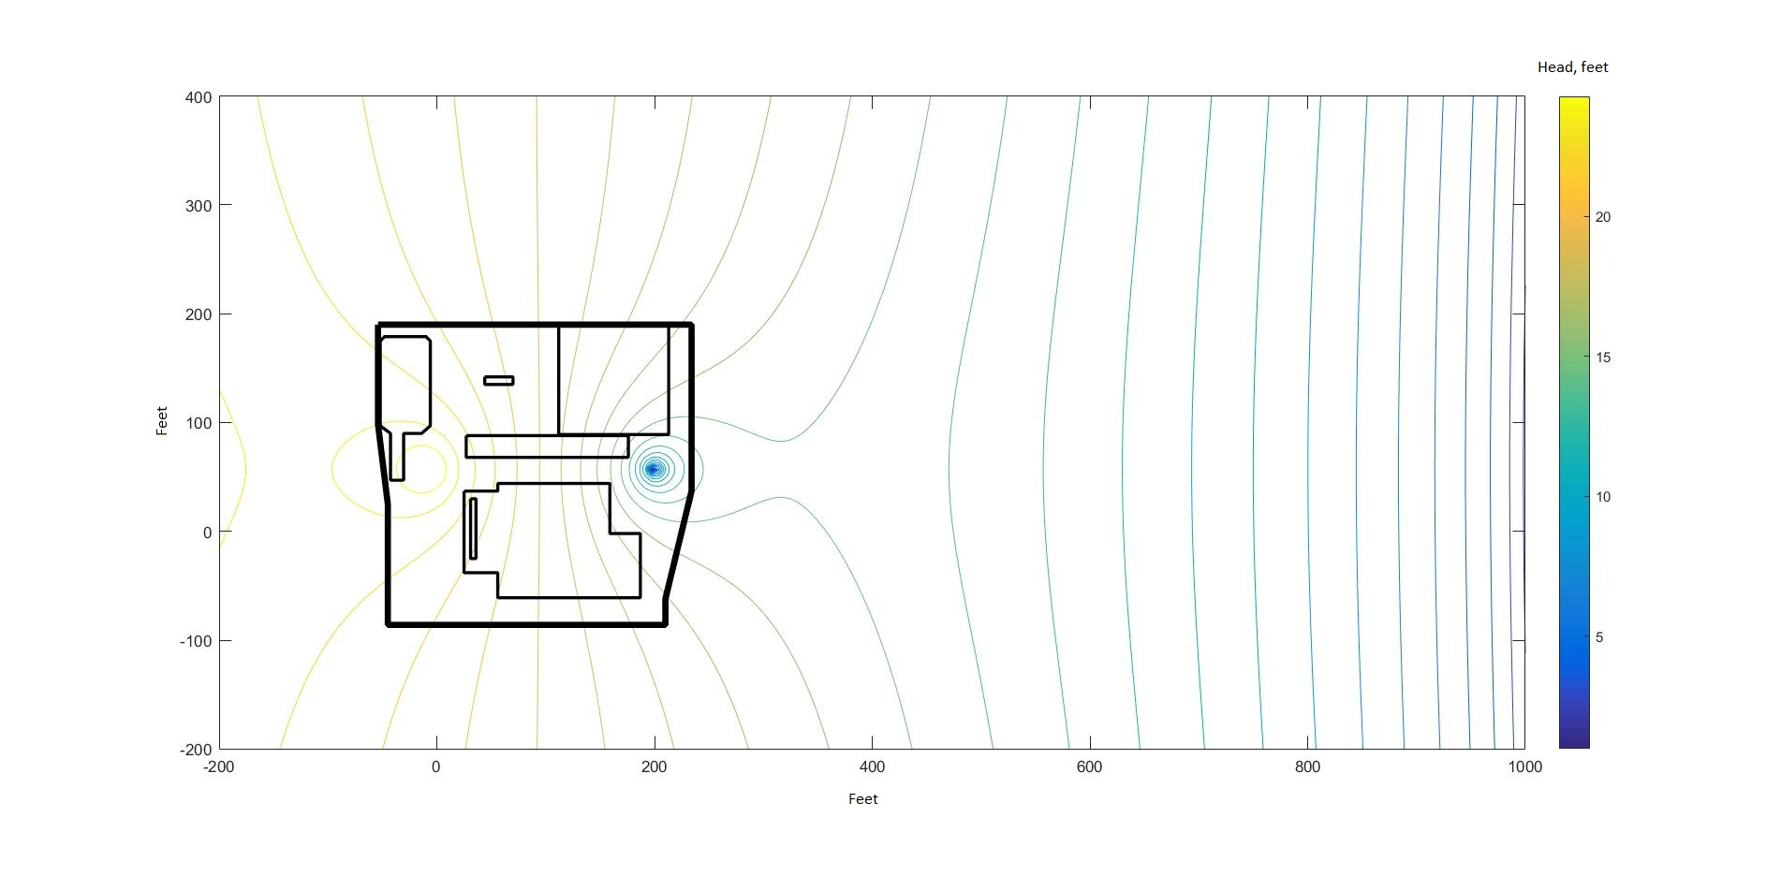

Figure 2: Head contours for the case of pumping 14000 cubic feet per day from a well located at (200,57) and depositing the water into an infiltration pond of radius 19 feet, located at (-9,57).

**Appendix 2 - Code**

|  |  |
| --- | --- |
| Runfile.m | z1= 200 + i*57; %pump out location  z2= -9+i*57; %pond location    Qx0 = 11.5; %ft/day    rp = 19;%pond radius ft  K = 58.6; %ft/day    Q = 14000; %ft^3 per day  N = Q/(rp*rp*3.1415);%infiltration rate, feet per day  rw = .3;%well radius, feet    %constant calculation, at x= 1000 re(omega) = 1.8*1.8*K*0.5  C = 1.8*1.8*K*.5 -real(Omega_total(1000,Qx0,Q,z1,z2,rw,rp,N));  ContourMe_flow_net_site(-200,400,800,-200,400,800,@(z)Omega_total(z,Qx0,Q,z1,z2,rw,rp,N),100);    %ContourMe_R_int(-200,1000,200,-200,400,200, @(z)Omega_to_phi_UNC(Omega_total(z,Qx0,Q,z1,z2,rw,rp,N)+C,K),25); |
| ContourMe_flow_net_site.m | function [Grid] = ContourMe_flow_net_site(xfrom, xto, Nx, yfrom, yto, Ny, func,nint)  Grid = zeros(Ny,Nx);    X = linspace(xfrom, xto, Nx);  Y = linspace(yfrom, yto, Ny);    for row = 1:Ny  for col = 1:Nx  Grid(row,col) = func( complex( X(col), Y(row) ) );  end  end    Bmax=max(imag(Grid));  Bmin=min(imag(Grid));  Cmax=max(Bmax);  Cmin=min(Bmin);  D=Cmax-Cmin;  del=D/nint;  Bmax=max(real(Grid));  Bmin=min(real(Grid));  Cmax=max(Bmax);  Cmin=min(Bmin);  D=Cmax-Cmin;  nintr=round(D/del);    figure;  hold on  contour(X, Y,real(Grid),nintr,'r');  contour(X, Y,imag(Grid),nint,'b');  legend('Equipotentials','Streamlines')    axis square  axis equal    %Burris boundary  x=[-54,234,234,210,210,-45,-45,-54,-54];  y=[190,190,37,-62,-86,-86,25,98,190];  plot(x,real(y),'k', 'LineWidth', 4)  hold on    %Injection FTWR ehse  x= [112, 213, 213,112,112];  y= [190,190,89,89,190];  plot(x,real(y),'k', 'LineWidth', 2)  hold on    %Office-Shed  x= [27,176,176,27,27];  y= [88,88,68,68,88];  plot(x,real(y),'k', 'LineWidth', 2)  hold on  %Burris WHSE  x= [25,56,56,159,159,187,187,56,56,25,25];  y= [37,37,44,44,-2,-2,-61,-61,-38,-38,37];  plot(x,real(y),'k', 'LineWidth', 2)  hold on  %Tank farm  x= [-52,-48,-10,-6,-6,-14,-30.5,-30.5,-42.5,-42.5,-52,-52];  y= [175,179,179,175,97,90,90,47,47,90,97,175];  plot(x,real(y),'k', 'LineWidth', 2)  hold on  %South SW drain  x= [31,36,36,31,31];  y= [30,30,-25,-25,30];  plot(x,real(y),'k', 'LineWidth', 2)  hold on  %Norht SW drain    x= [44,70,70,44,44];  y= [142,142,135,135,142];  plot(x,real(y),'k', 'LineWidth', 2)  hold on  %hold on  %contour(X, Y,real(Grid),nintr);  %contour(X, Y,imag(Grid),nint);  %axis equal |
| ContourMe_R_int.m | function [Grid] = ContourMe_R_int(xfrom, xto, Nx, yfrom, yto, Ny, func,nint)  Grid = zeros(Ny,Nx);    X = linspace(xfrom, xto, Nx);  Y = linspace(yfrom, yto, Ny);    for row = 1:Ny  for col = 1:Nx  Grid(row,col) = func( complex( X(col), Y(row) ) );  end  end  contour(X, Y, real(Grid),nint);  axis equal  hold on  colorbar    %Burris boundary  x=[-54,234,234,210,210,-45,-45,-54,-54];  y=[190,190,37,-62,-86,-86,25,98,190];  plot(x,real(y),'k', 'LineWidth', 4)  hold on    %Injection FTWR ehse  x= [112, 213, 213,112,112];  y= [190,190,89,89,190];  plot(x,real(y),'k', 'LineWidth', 2)  hold on    %Office-Shed  x= [27,176,176,27,27];  y= [88,88,68,68,88];  plot(x,real(y),'k', 'LineWidth', 2)  hold on  %Burris WHSE  x= [25,56,56,159,159,187,187,56,56,25,25];  y= [37,37,44,44,-2,-2,-61,-61,-38,-38,37];  plot(x,real(y),'k', 'LineWidth', 2)  hold on  %Tank farm  x= [-52,-48,-10,-6,-6,-14,-30.5,-30.5,-42.5,-42.5,-52,-52];  y= [175,179,179,175,97,90,90,47,47,90,97,175];  plot(x,real(y),'k', 'LineWidth', 2)  hold on  %South SW drain  x= [31,36,36,31,31];  y= [30,30,-25,-25,30];  plot(x,real(y),'k', 'LineWidth', 2)  hold on  %Norht SW drain    x= [44,70,70,44,44];  y= [142,142,135,135,142];  plot(x,real(y),'k', 'LineWidth', 2)  hold on |
|  |  |
| Omega_pond.m | function [ Omega ] = Omega_pond(z,z0,rp,Q, N)  rsq=(z-z0)*conj(z-z0);  if rsq>rp^2  Omega=-(Q/(2*pi))*log((z-z0)/rp);  else  Omega=-(1/4)*N*((z-z0)*(conj(z)-conj(z0))-rp*rp);    end |
| Omega_Uniformflow.m | function [ Omega ] = Omega_Uniformflow (Qx0,z)  Omega = -Qx0*z;  end |
| Omega_well.m | function [ Omega ] = Omega_well(z,z0,rw,Q)  rsq=(z-z0)*conj(z-z0);  if rsq>rw^2  Omega=Q/(2*pi)*log(z-z0);  else  Omega = 0;    end |
| Omega_to_phi_UNC.m | function [ phi ] = Omega_to_phi_UNC (Omega, K)  phi = sqrt(2*real(Omega)/K);  end |
| Omega_total.m | function [ Omega ] = Omega_total( z, Qx0,Q, z1,z2,rw,rp,N)  Omega=Omega_Uniformflow(Qx0,z) + Omega_well(z,z1,rw,Q) + Omega_pond(z,z2,rp,Q, N);    end |

**Appendix 3 - References**

1. Strack, Otto D. L. *Analytical Groundwater Mechanics*. Cambridge University Press, 2017.